5. Draw a UML diagram for a food ordering system Systems. The activities of the food
ordering system are listed below. Receive the Customer food orders, Produce the
customer ordered food, Serve the customer with their ordered food, collect payment
from Customers, Store customer payment details, Order Raw Materials for food
products, Pay for Raw Materials and Pay for Labour.

AIM:

To design a UML diagram for an online food ordering system.

PROCEDURE:

Identify Actors:
- Customer: Places orders.
- Kitchen: Prepares the ordered food.
- Payment System: Processes payments.
- Supplier: Provides raw materials for food preparation.
Define Use Cases:
- Receive customer orders.
- Prepare food as per the order.
- Serve the food to the customer.
- Collect payment from the customer.
- Store customer payment details.
- Order raw materials for food production.
- Pay for raw materials and labor.
Create Diagrams:
- Use Case Diagram: Maps interactions between actors and system functionalities.
- Class Diagram: Defines system components like customer orders, kitchen management, and payment handling.

DIAGRAM:
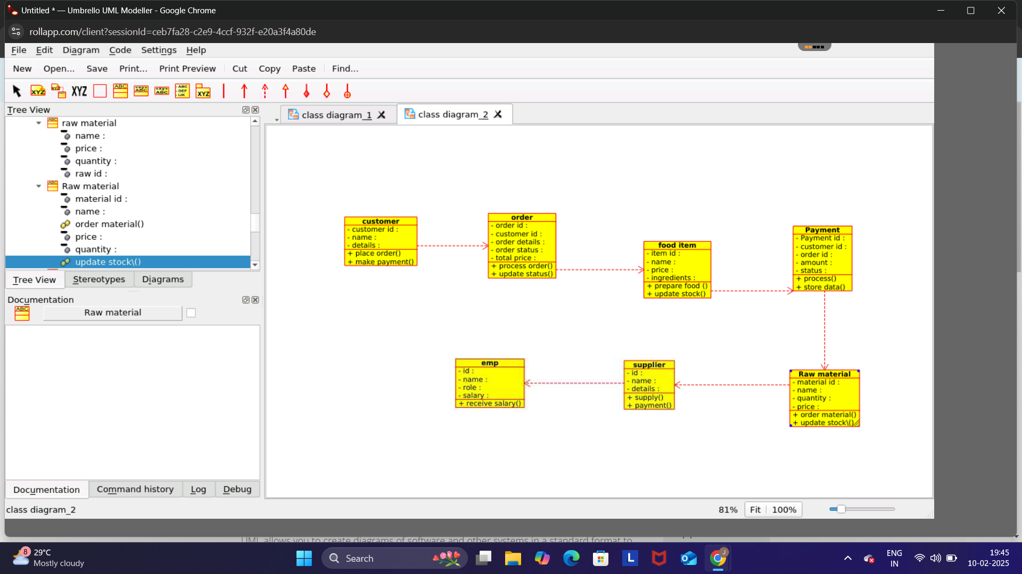
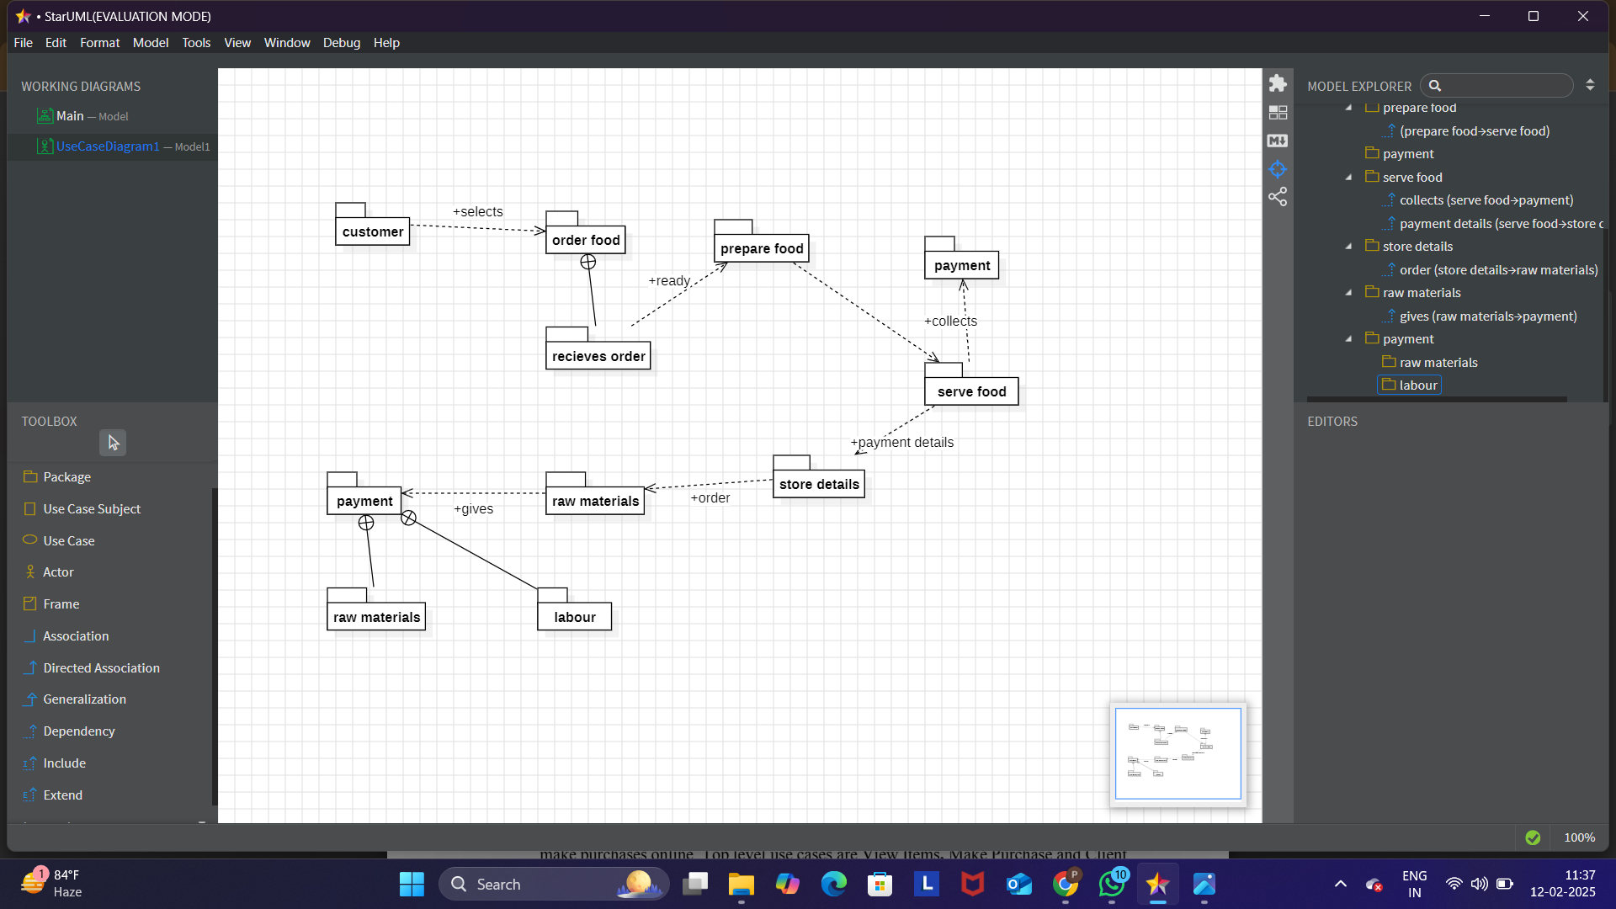

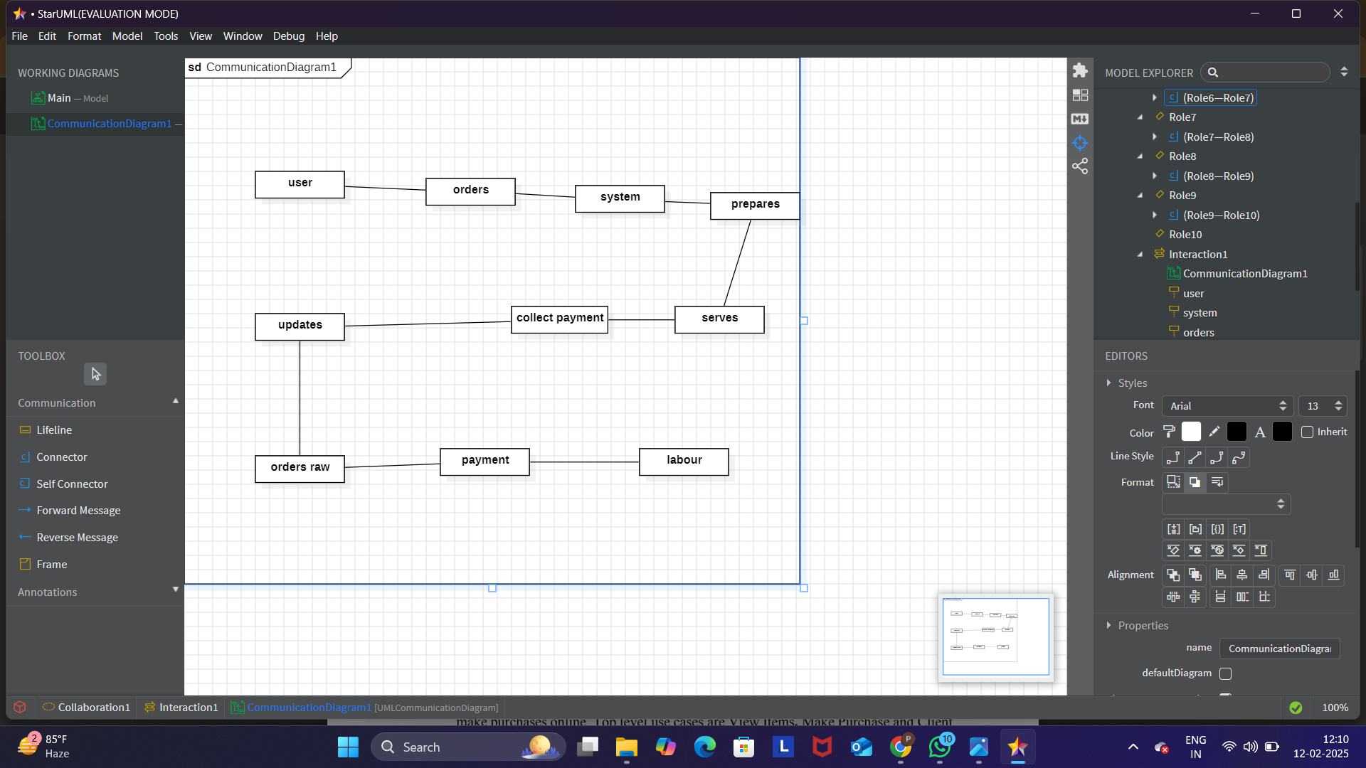
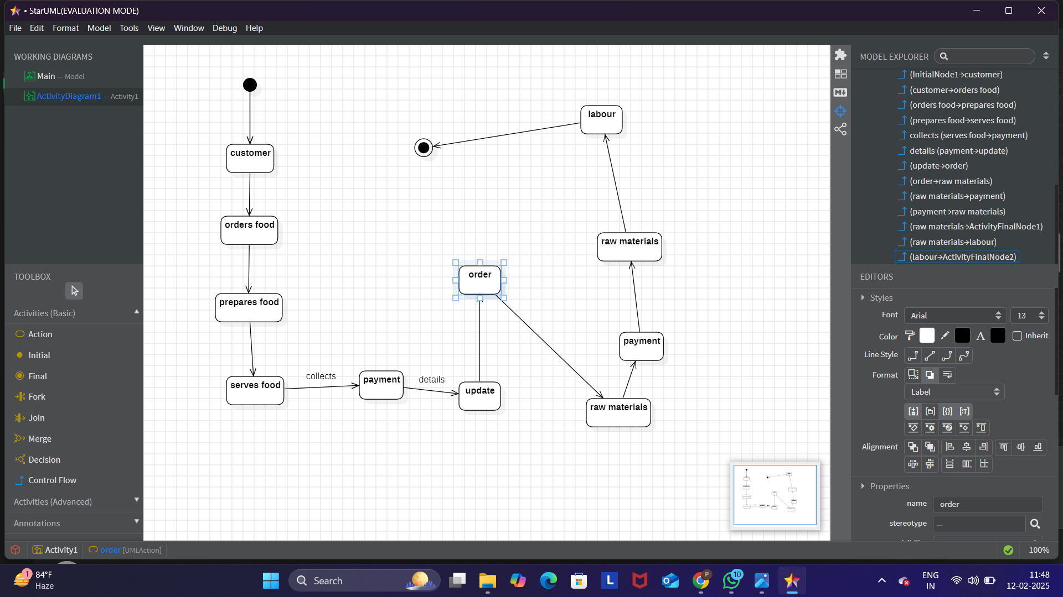
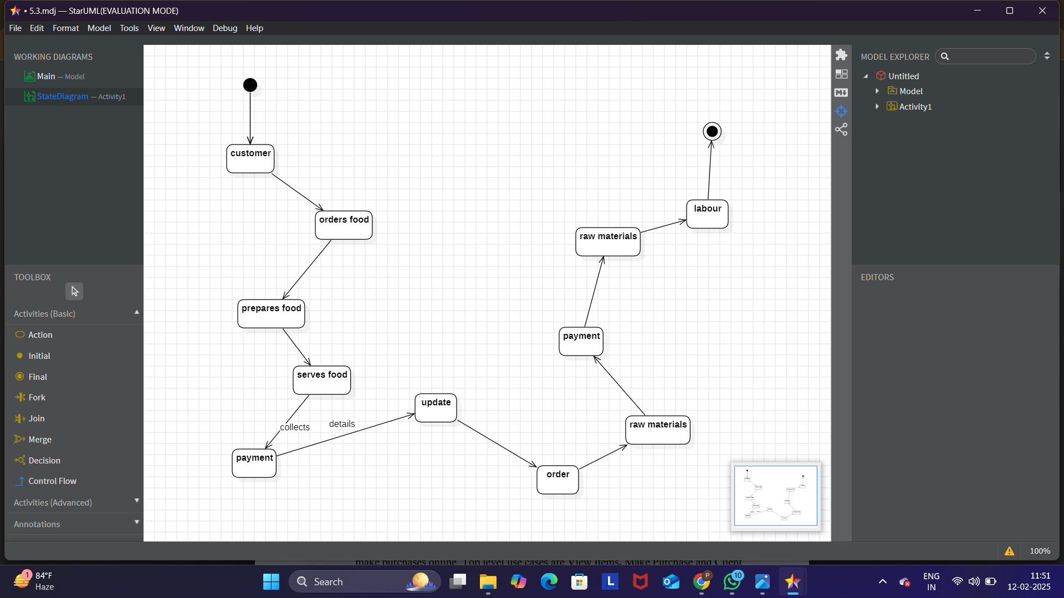
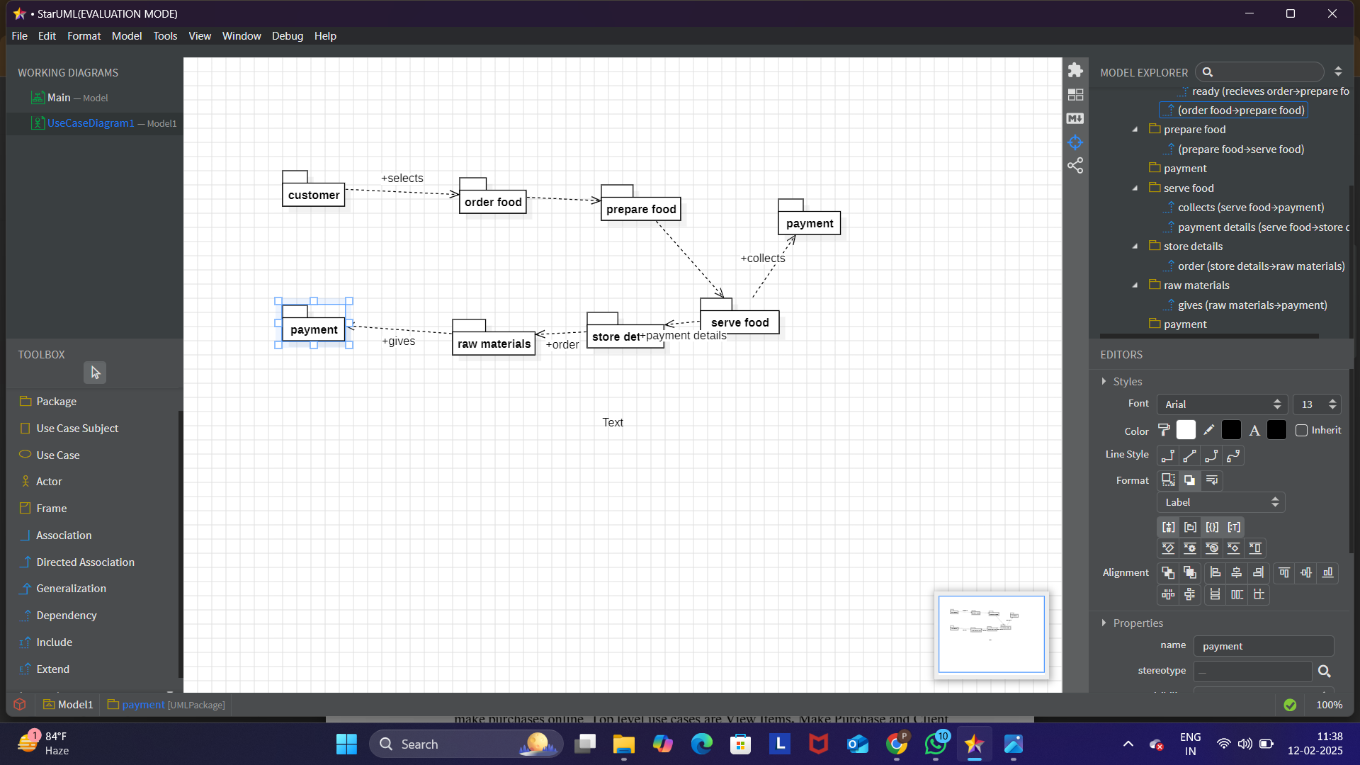
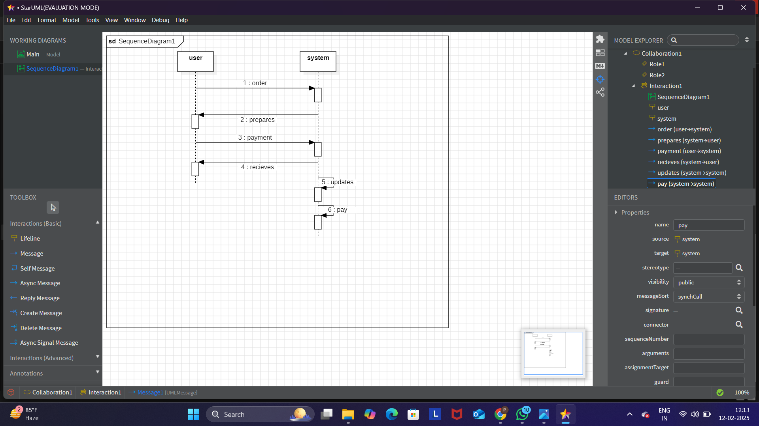
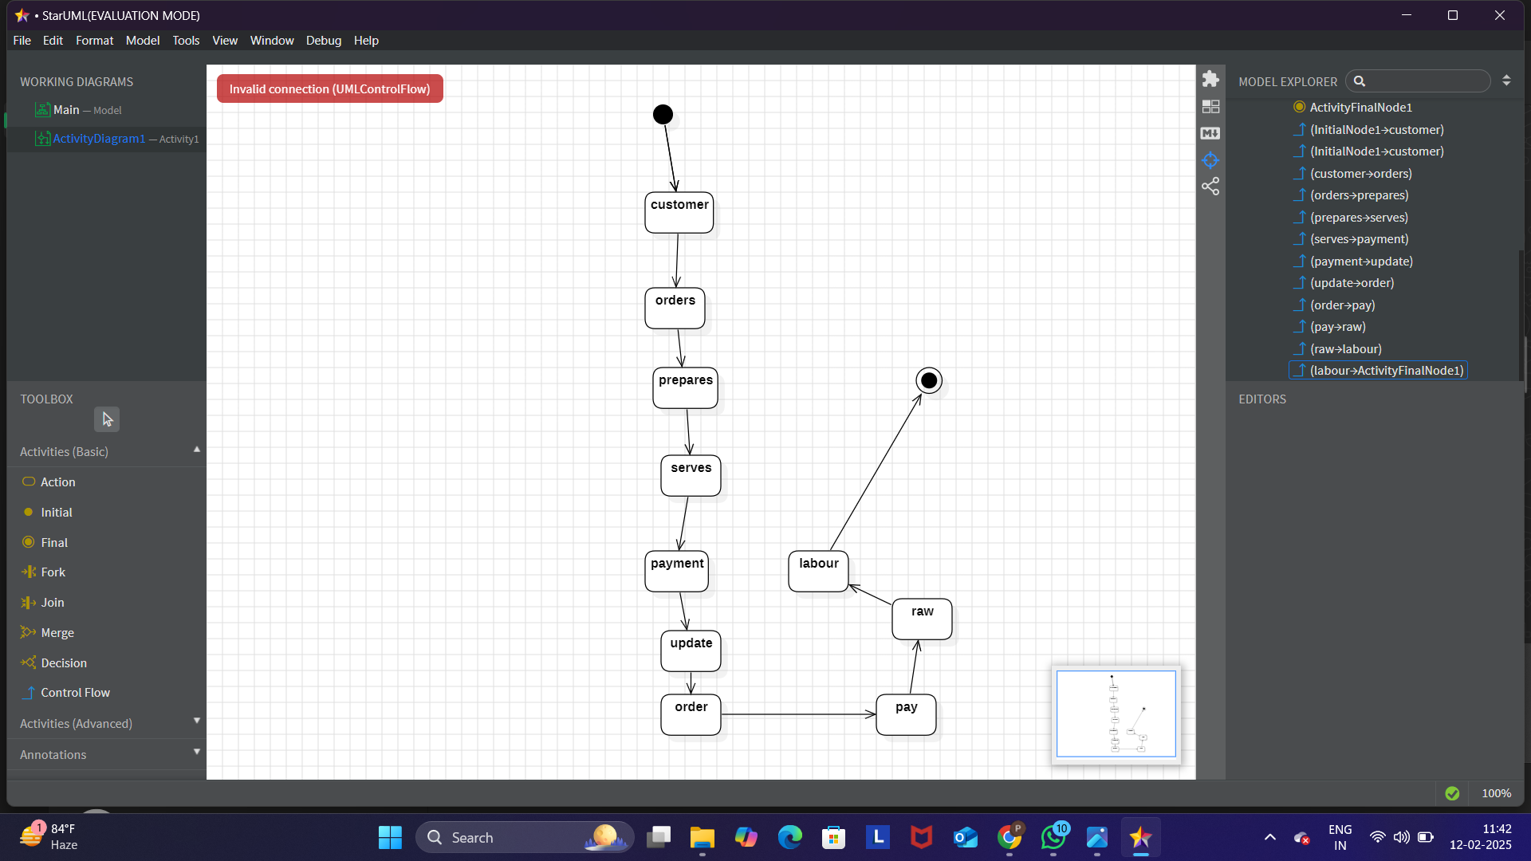

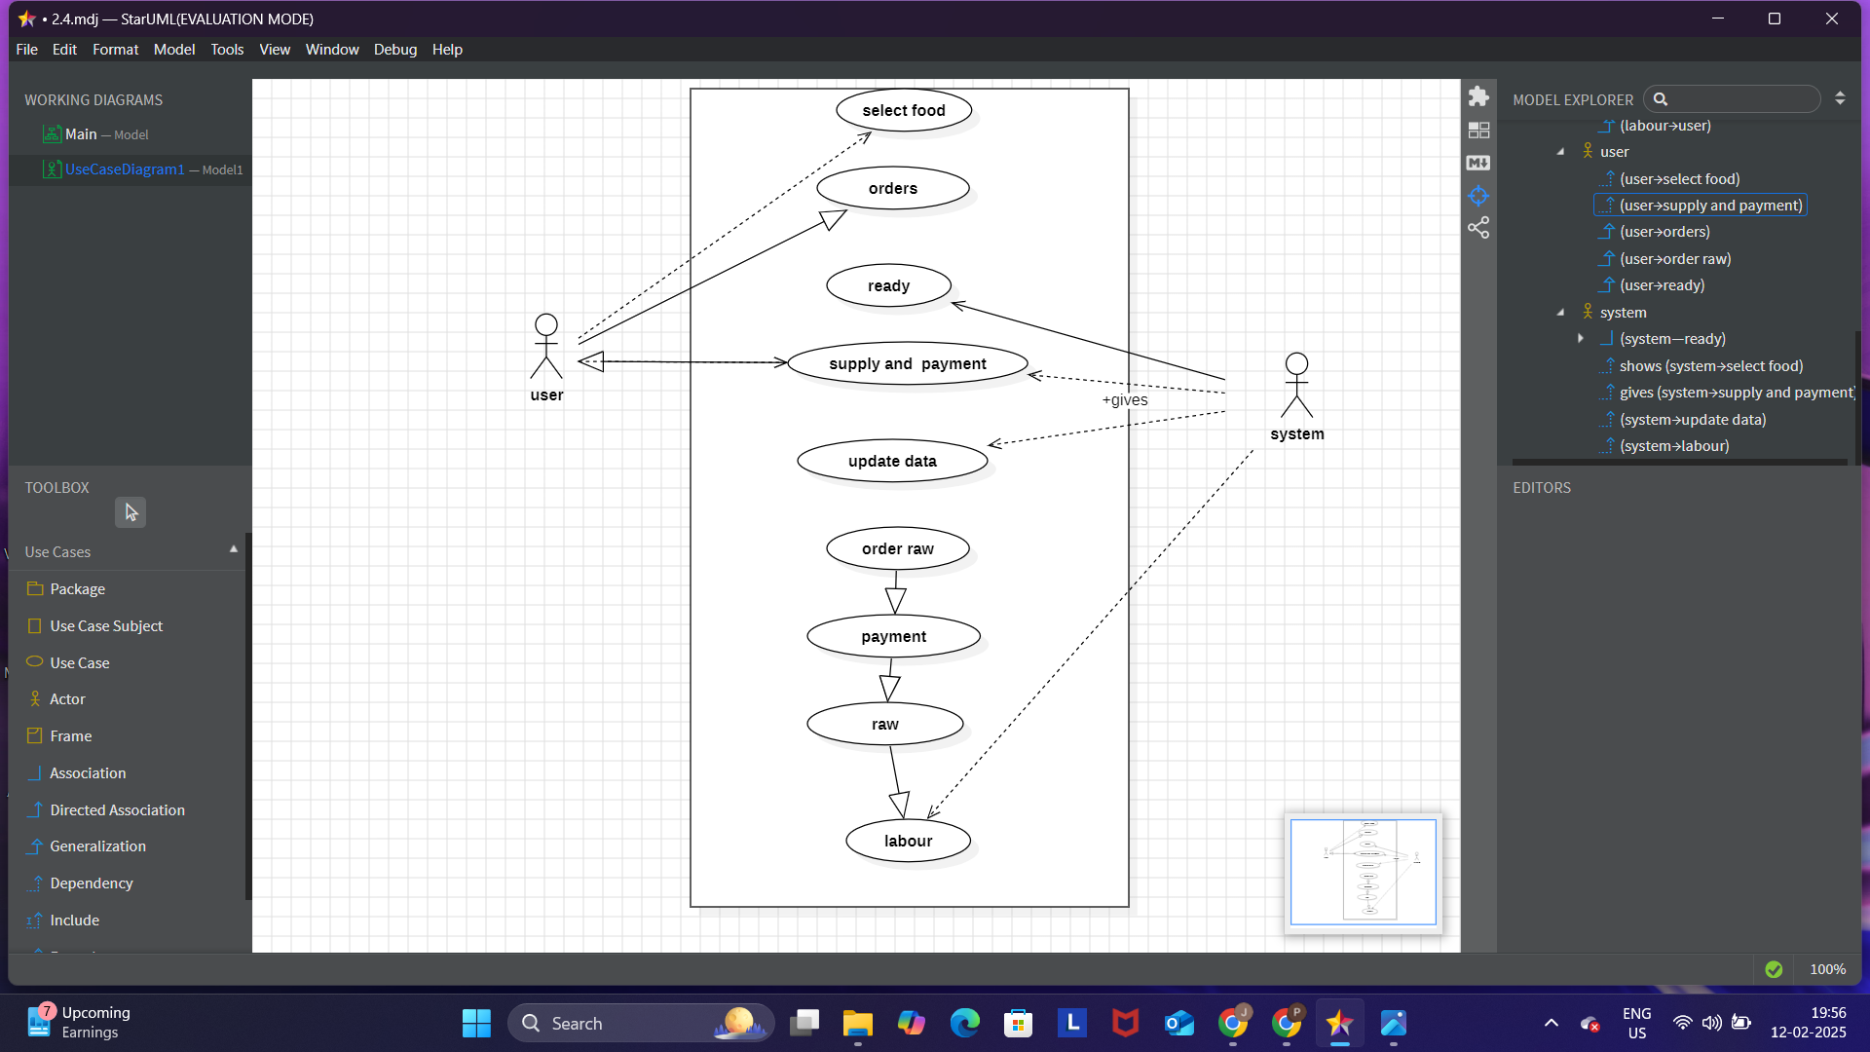

RESULT:
The UML diagrams provide a structured representation of the food ordering system ensuring clear understanding and efficient system design.

